How-to Guide: Milk price calculator
The Milk price calculator (MPC) consists of two parts:
- Personal milk profile – provides milk prices for a range of contracts based on your farm’s milk profile
- League table – shows milk prices for a range of contracts based on milk matching the profile of the AHDB standard litre

Milk price calculator - Personal milk profile
This tool allows you to compare the monthly and annual average milk price you would receive on different contracts as determined by your personal milk profile.
You are able to input data to reflect your current milk profile, or a hypothetical milk profile, allowing you to see the impact on milk prices of changing various characteristics (such as fat or protein content, delivery profile or hygienic quality).
To calculate the milk prices, you will need to complete the grid and choose the relevant options to best match your situation.

Contract type
Firstly, select the ‘Contract type’ you are interested in from the dropdown menu. A number of options are available, from liquid to manufacturing but the default is to show ‘All contract types’.

Region
You can select the GB region from the ‘Regions’ dropdown with the default being ‘All regions’. By choosing a region, the output will show only prices paid on contracts normally available in the selected region.
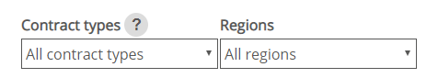

Collection frequency
Select either EODC (every other day collection) or EDC (every day collection) as appropriate.
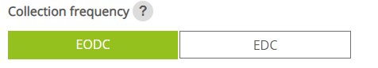

Milk profile
You can choose either a Fixed or Varied milk profile for calculating milk prices.
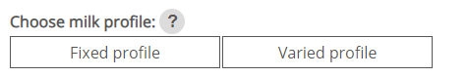
Fixed profile provides a grid where butterfat, protein, somatic cell count and bactoscan remain fixed through the year but milk delivery volumes can vary.
Varied profile provides a grid which allows you to enter monthly values for butterfat, protein, somatic cell count, bactoscan and milk deliveries.

Complete grid
There are three ways to enter your data into the grid: Enter data manually; Import from file; Pick preset profile.
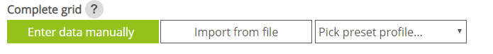
Note: there must be an entry in each cell for the calculator to work. In cases where no milk is produced in a month, a 0 should entered into the grid.
Butterfat and protein figures should be entered to 2 decimal places. All other numbers should have no decimals. Do not use commas to separate thousands.
Enter data manually:
Choosing this option provides a grid with zero values in all cells. You can overwrite these by clicking in the cell (cursor will blink in the active cell), and replacing the zero with your own numbers.

Import from file:
To import your own profile data, follow these steps:
- create an Excel file as per the example below
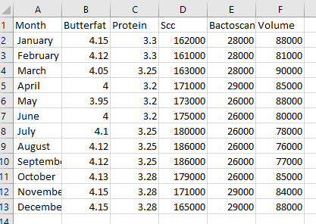
two decimal places should be used for butterfat and protein and no commas should be used to separate thousands
- Save your file with a .xlsx or .CSV file extension
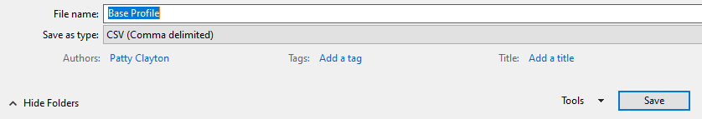
- Return to the MPC screen and select ‘Import from file’
You can now choose your saved file from its file location, then click Open.
- The data will now be uploaded into the grid.
Pick preset profile:
This allows you to choose from three preset milk profiles shown in the drop-down menu: Standard Litre; Spring Profile; Autumn Profile.
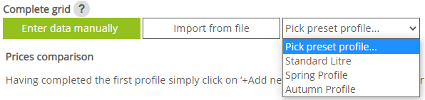
By choosing this option, the grid will be populated automatically. For example, by choosing the ADHB standard litre from the drop-down menu, the grid will be populated with values corresponding to the milk profile used to calculate the League table prices. The two other options available are typical example profiles for Spring and Autumn block calving.

Calculate prices
Once the grid is completed, you can generate the table of contract prices by clicking on the Calculate prices button. The table of results, along with the milk profile can be printed or downloaded by clicking on the relevant icons.


Comparing different milk profiles
You can key in or upload up to five different profiles by clicking on +Add new profile and then either keying in your data or uploading CSV files.
Note: this option is not available when you use the preset profiles
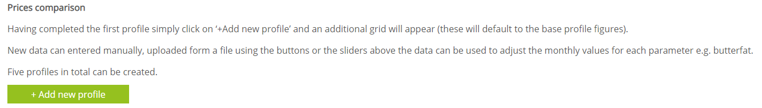
When you choose to add a new profile, you will be asked to select how to enter the data (manually or import file)
In the new profiles, you can vary the values for each parameter by up to 50% using the sliders or by manually overtyping the data.

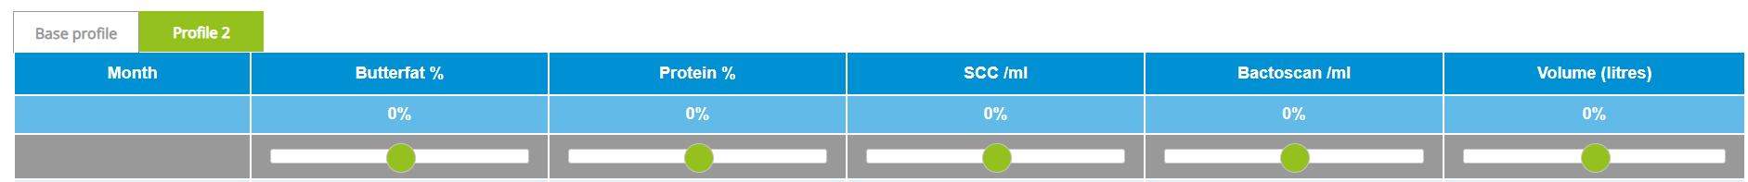

To remove the additional profiles then click ‘Remove added profiles’. Note however, that this will remove ALL added profiles, not just the most recent one.
When you download the results of multiple profiles as an Excel file you will be able to see a table containing all the monthly prices as well as the annual prices for each milk schedule. Below this is a cashflow table which shows the revenue you would receive based upon the monthly volumes you entered and the monthly prices for each contract. The cashflow results are also presented in graphical form. The charts show more easily how revenue changes over the months due to the seasonality of payments and production.

League table

To view the latest League table of milk prices based uon the AHDB standard litre milk profile, please select the League table tab



This will display a table of milk prices by contract type in alphabetical order. Contracts can be sorted in order of contract name, monthly and annual price.
Notes regarding the contracts can be viewed by hovering over the question mark symbol.
To view the AHDB standard litre milk profile, click on the Milk composition details link.
An Excel file of results can be downloaded by clicking on the ‘Download prices’ icon. Alternatively, it is possible to print the League table using the print icon provided.
If you have further questions, please email datum@ahdb.org.uk or call 02476 478847.

